S1-2021

The shown mechanism is in a vertical plane. From a disk of mass **m**, radius **R**, a disk of radius is cut with a center at the middle of the horizontal radius.

In what limits does the value of the force **P** changes, ensuring the immobility of the weight **Q** in the given position of the mechanism if the coefficient of friction between the slider **A** and the directing is equal to **f**. Neglect the masses of the rods and friction in the hinges. The rods are hinged to each other, rod **1** is tightly fixed to the disk.

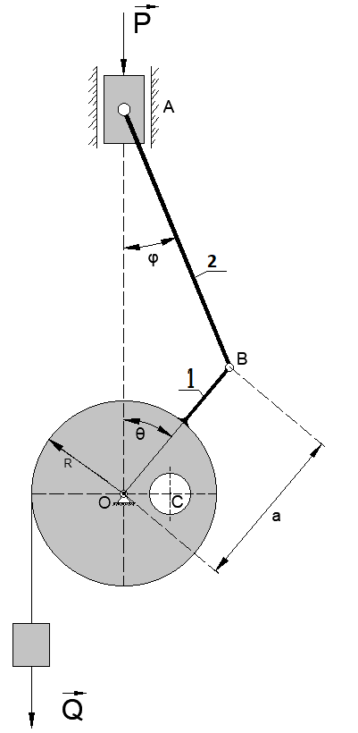

S2-2021

The crank mechanism **OAB** is connected in the middle connecting rod **AB** with a cylindrical joint **C** with a rod **CD.**  Rods **CD** and **DE** are connected by a cylindrical joint **D**.

Forces **P1=P, P2=2P, P3=2P.** are applied to the middle of the rods.

Determine the relationship between the magnitudes of the forces **FA**, **FD**, accordingly perpendicular to the rods **OA** and **DE** when the mechanism is in equilibrium in the position shown in the picture.

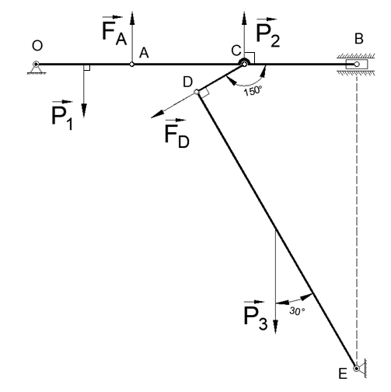

К1-2021

Crank **OA = R** rotates around point **O** in the plane drawing. The connecting rod **AB** is pivotally connected to the end of the crank at point **A** and passes through a cylindrical joint that can rotate around a fixed center **N**

**AB = 3R**. Determine the radius of curvature of the path

points **B** in at  **.**

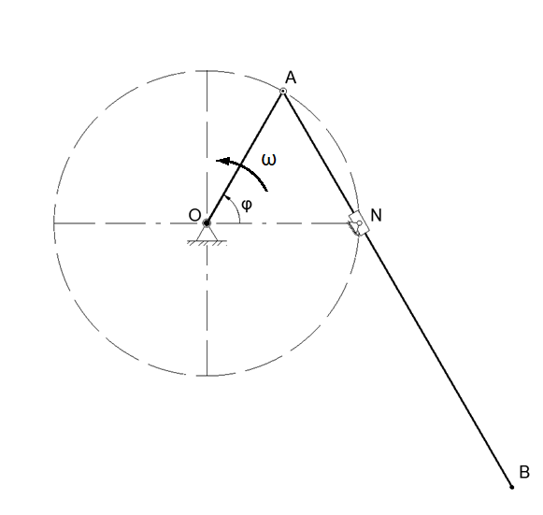

K2-2021

Couplings **A** and **B**, sliding along rectilinear generators, are pivotally connected to a rod **AB** of length **L**. Coupling **A** moves at a constant speed . The rod starts moving from a horizontal position. Point **M** moves along the rod according to the equation **BM = Lsin**. Determine the acceleration of point **M** at the indicated moment.

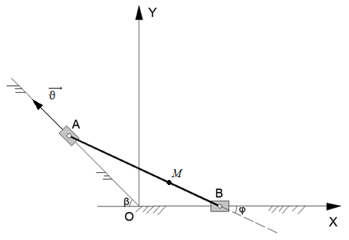

D1-2021

The cylinder of mass **m1** is on a bogie with a mass of **m2**. The system is equipped with a damping device, in which a resistance arises proportional to the relative velocity of the cylinder axis, . The initial relative velocity of was reported to the cylinder axis. The cylinder rolls on the bogie without sliding. A horizontal force is applied to the trolley **F = const**

Define:

1) At what point in time the relative velocity of the cylinder axis will be equal to zero.

2) The acceleration of the cart at this moment in time.

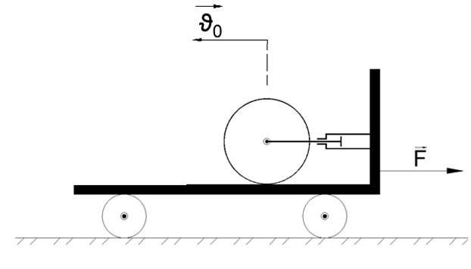

D 2-2021

A wire bent in the form of a curve **y = x²** is located in the vertical plane. A ring of mass **m** is put on the wire. The ring is released from the point with the abscissa without initial velocity. A force is applied to the ring ( is the radius-vector of the ring drawn from the origin).

Determine the force of pressure of the ring on the curve when passing through a point with an abscissa equal to **x = 1**.

There is no friction between ring and curve.